HOW TO SUBMIT A PAPER TO THE PURCHASE COLLEGE JOURNAL OF ECOLOGY

Allyson K. Jackson and Ben D.O.G. Jackson

ABSTRACT
The Purchase College Journal of Ecology is a peer-reviewed journal in the General Ecology course. This paper illustrates how to format a paper for submission and what should appear in each section. The abstract contains a summary of the entire paper – including the results and major points of your discussion. The abstract should definitely contain spoilers giving away what you found; the abstract is not a teaser for the rest of the paper.
Keywords. Guidelines; Model
______________________________________________________________________________

INTRODUCTION
An introduction should start broad and set the stage for what you are studying. The first paragraph should have a global spin on your issue. The best way to organize this section is to proceed from the "general" to "specific". Are you studying water striders on Purchase College campus? Start your introduction with a broad paragraph explaining threats to freshwater health globally. Are you studying predator avoidance in eastern chipmunks? Start your introduction with an explanation of how and why predator avoidance has evolved in some animals.
In future paragraphs, narrow your focus to what you are studying. What is the question(s) you are asking? What organism or system are you studying? Why is it worthwhile to study this system? Give appropriate background information (i.e., what is already known about the subject?). Your job here is to orient the reader to what your paper is about and to explain why it is interesting.
Your introduction should include citations from the primary literature to back up your statements. When citing literature write the name and then the year without a comma: (Rotella 1992). Place comas between articles cited in conjunction or between years indicating different articles of the same author: (Barr 1986, Heinz 1976, 1979, Scheuhammer and Blancher 1994, Tejning 1967). List articles alphabetically in this instance.
The final paragraph before starting the methods section should clearly state your goals and hypothesis. For example, if you were studying small mammals- our goal is to study the relative abundance of small mammals (eastern chipmunk and eastern gray squirrel) on the Purchase College campus. Our hypothesis is that diversity and abundance will be higher in areas with more acorns.

METHODS
Describe the methods and materials you used to obtain your results (test your hypotheses) in sufficient detail that someone else could repeat your research. Be sure to describe sampling (experimental) design and statistical procedures used. This needs a rather annoying amount of information. For example, it is not enough to say you used ethanol, you need to state what strength it was. Include what brand of equipment you used. You need to provide enough information for someone to replicate it exactly! Use the past tense throughout.
Field site. This section is sometimes included as a separate heading in ecological papers. Briefly describe the environment of your study site. Include physical, chemical, and biotic aspects.
Statistical analysis. This is another potential subheading within methods. Even without the subheading, you need to make sure you explain clearly what statistics you used.
Standards for scientific writing. Use digits for numbers (e.g., 7 and 45) unless the number is the first word of a sentence, where it is spelled out. Use symbols or abbreviations (e.g., % and kg) for measurement units that follow a number unless the number is indefinite (thousands of hectares), is a "0" (zero) standing alone, or is the first word. In such cases spell out the number and unit name or recast the sentence. Spell out numbers used as pronouns (i.e. one) or adverbs and ordinal numbers (e.g., first and second). Do not use naked decimals (i.e., use 0.05, not .05). Do not capitalize common names of species except words that are proper names (e.g., Canada goose [Branta canadensis], Swainson's hawk [Buteo swainsoni], versus white-tailed deer [Odocoileus virginianus]).
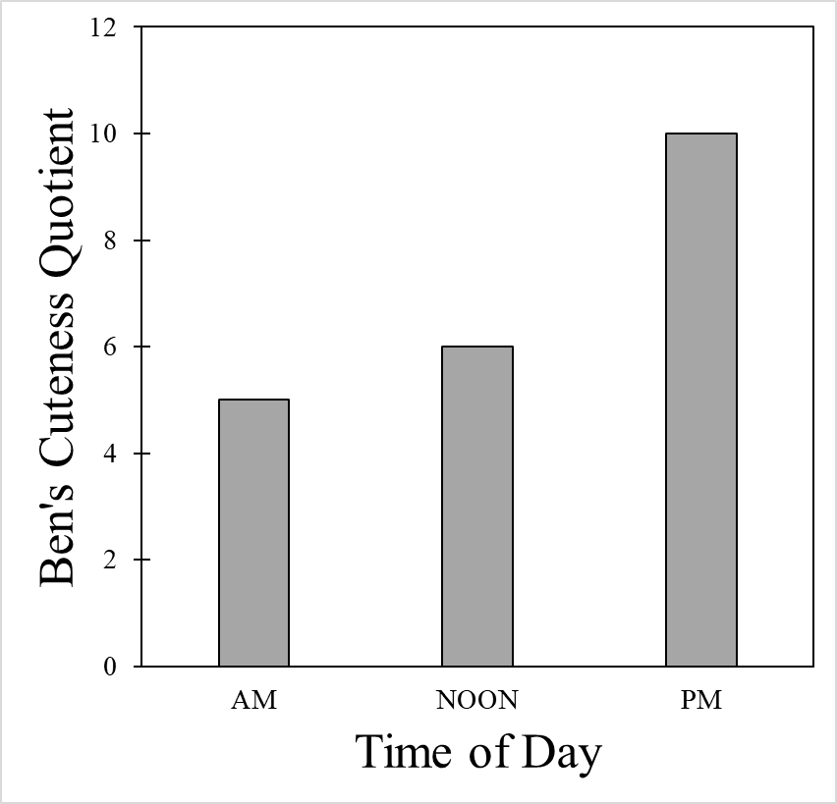
Standards for this journal. All font (including figures, tables, and captions should be in Times New Roman. All major headings should be in size 12 font. All text should be size 11.

RESULTS
What did you find? In this section you should only describe your findings without explanation or interpretation. There should be no literature citation in this section (only in introduction and discussion).
Illustrate with figures and/or tables, which are numbered independently. Include titles for tables (Table 1) and legends for figures (Fig. 1). Insert tables and figures in text. Be sure to describe all tables and figures verbally in the text. Be sure to give units of measurement, sample sizes, and the results of your statistical tests (e.g., for t-tests include the t value and its probability; for correlation tests include r value and its probability; etc. Tables are labeled above and figures below. Labels should be able to describe the table or figure in such a way that you can understand the table without having to read any of the paper. Include year of data collection and general location (i.e., Pennsylvania). Construct tables for column-width printing; do not exceed the normal margins of the paper. Figures and tables should be shown in grayscale whenever possible. Tables should include lines above and below the headings and at the bottom of the table (but no others).
Figure 1. Ben’s quotient of cuteness related to time of day. Figure captions always go below the figure.

Table 1. Table captions go above the table.
Time of Day | Behavior observed
AM | sleeping, looking cute
NOON | tail wagging, looking cute
PM | eating, running, looking cute

DISCUSSION
Discussions generally mirror the introduction in that they start very specific and then fan out to talk about your work broadly. In the first paragraph, you want to summarize what you found in this study. Discussion sections should be 3-5 paragraphs long
In future paragraphs, you can explore what your results mean. What do you conclude from your results? Did anything unexpected happen. Explain why. What further research could be done to clarify your findings? Compare your results with those in the literature. Be sure to use internal citations to cite primary literature. We will spend an entire lab section talking about how to find and cite primary literature.

CONCLUSIONS
In the conclusions section, write a short (2-4 sentence) summary of your findings and why they are important. You know you sometimes only read the abstract and discussion of papers, so put some thought into this.

ACKNOWLEDGEMENTS
Here is a good place to thank anyone who helped with your research. Ben would like to thank the makers of Blue Buffalo dog food for making their kibble so delicious.

LITERATURE CITED
All published work cited in your paper. Between your introduction and discussion, you should have at minimum 4 journal articles per group member (i.e., two person groups = 8 articles). Follow the format of Ecology. Be sure to double-space between references. It is important that you follow the format exactly. Editors of scientific journals expect that submitted papers follow precisely the guidelines of the journal. This ensures consistency and high quality of all papers published in the journal.
Examples follow:
For a book-
Niklas, K.J. 1994. Plant allometry. University of Chicago Press, Chicago, Illinois, USA.
For a journal article-
Bowers, M.A. and J.H. Brown. 1992. Body size and co-existence in desert rodents: chance or community structure. Ecology 63: 391-400.
For a book chapter
Lawton, J.H. 1987. Are there assembly rules for successional communities? Pages 225-244 in A.J. Gray, M.J. Crawley and P.J. Edwards, editors. Colonization, succession and stability. Blackwell Scientific, Oxford, England.

